**MongoDB CRUD Operations**

CRUD means **Create** **Read** **Update** and **Delete**

Go to this website to learn more : <https://www.mongodb.com/docs/manual/crud/>

Here we need to understand 🡺

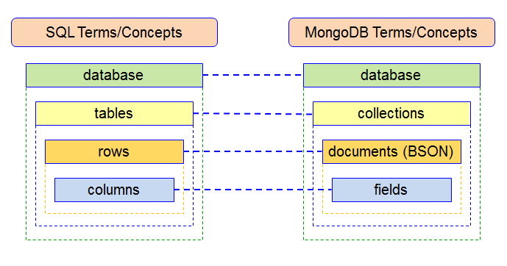

**Create Operations:**

Creating collections == **db.createCollection(“name”)**

In the collection insert document and fields

Here document means collection of fields



How to insert document and fields:

db.collection_name.insertOne({id:12, name : “someones name”, email:”abcd@gmail.com”})

here we can insert only one document

db.collection_name.insertMany([documents])

here we can insert many documents

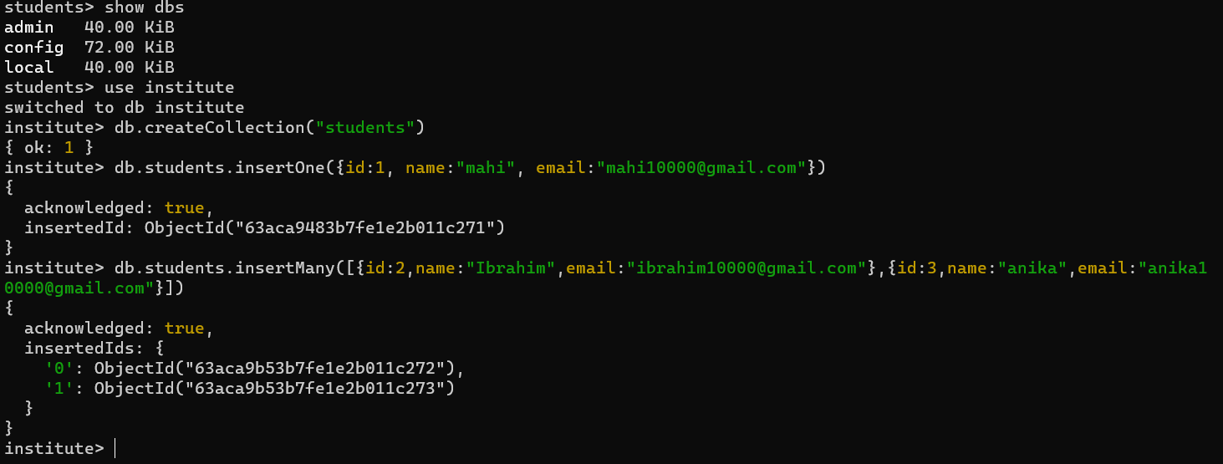

**Query or Read Operation :**

In previous section, we insert some document in a collection. How to see the documents.

To find All the documents:

db.collection_name.find()

Find specific document under a name :

db.collection_name.find({name:”name”})

Finding collections under limits:

db.collection_name.find().limit(5)[here we can see only 5 collections]

*practical uses:*

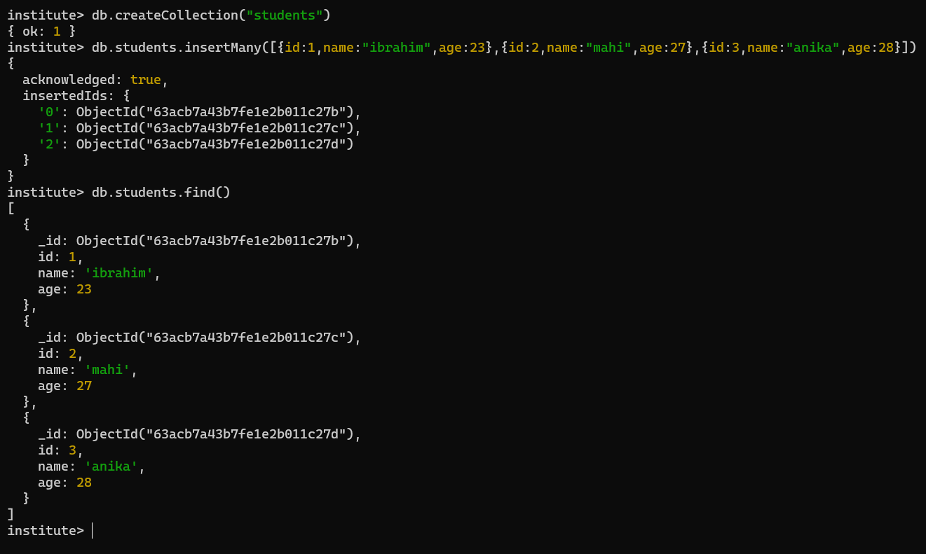

**Update Operation:**

How to update a document

db.collection_name.update({field_name:”field_value”},{$set:{field_name:”update_field_value”}})

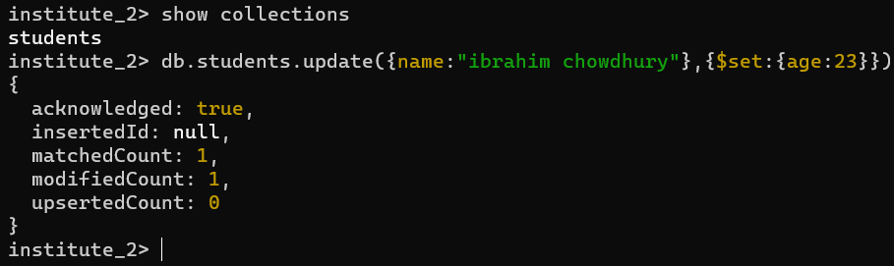

**Delete Operations:**

Delete operations:

db.collection_name.deleteOne({field_name:”field_value”})

db.collection_name.deleteMany( {field_name1:”field_value1”}, {field_name2:”field_value2”} )

